Design Document
Group A - Team Red Panda



Peter Grypma
Chris Hobbs
Hizkia Mertadiwangsa
David Wu

Table of Contents

Guidelines 2

Development Tools 2

Legal Issues 2

System Diagrams 2

Word Scramble UML Diagram 2

Missing Letters UML Diagram 2

Generic Menu Network 2

Data Requirements 2

Game Content Data 2

Settings Data 2

User Interaction 2

Feature Priority 2

Version 1 2

Version 2 2

Version 3 2

Guidelines

Development Tools

Team Red Panda will utilize the following tools throughout the development process of their apps:

- Primary IDE: Xcode by Apple Inc.
- Version Control: GitHub by GitHub Inc.
- Operating Platform: iOS by Apple Inc.
- Initial Testing: iOS Simulator by Apple Inc.
- Final Testing: Apple iPhone 4

Legal Issues

Any possible legal issues may come by inadvertently using a registered trademark or copyrighted material as well as possibly reproducing any patented methods of data manipulation.

System Diagrams

Word Scramble UML Diagram

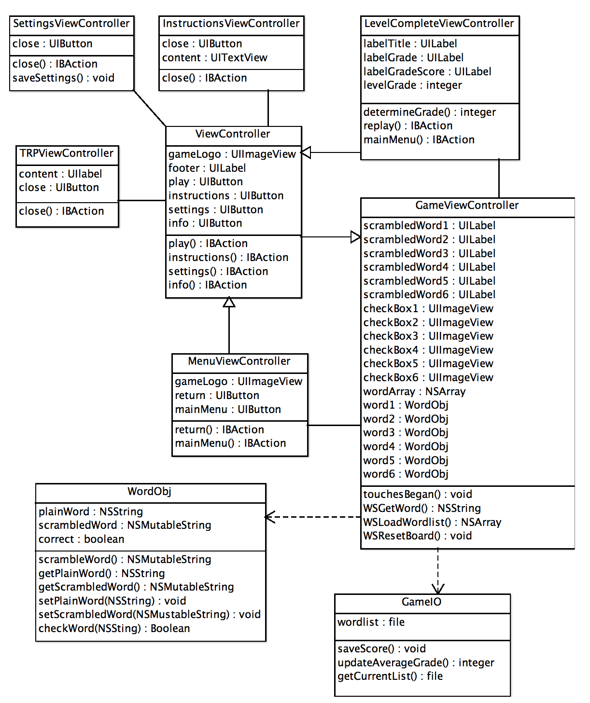

This UML Diagram show the different classes used in Word Scramble and how they interact with each other. Some action and UI element may not be show in this diagram as they are automatically defined by the Xcode storyboard editor.

Missing Letters UML Diagram
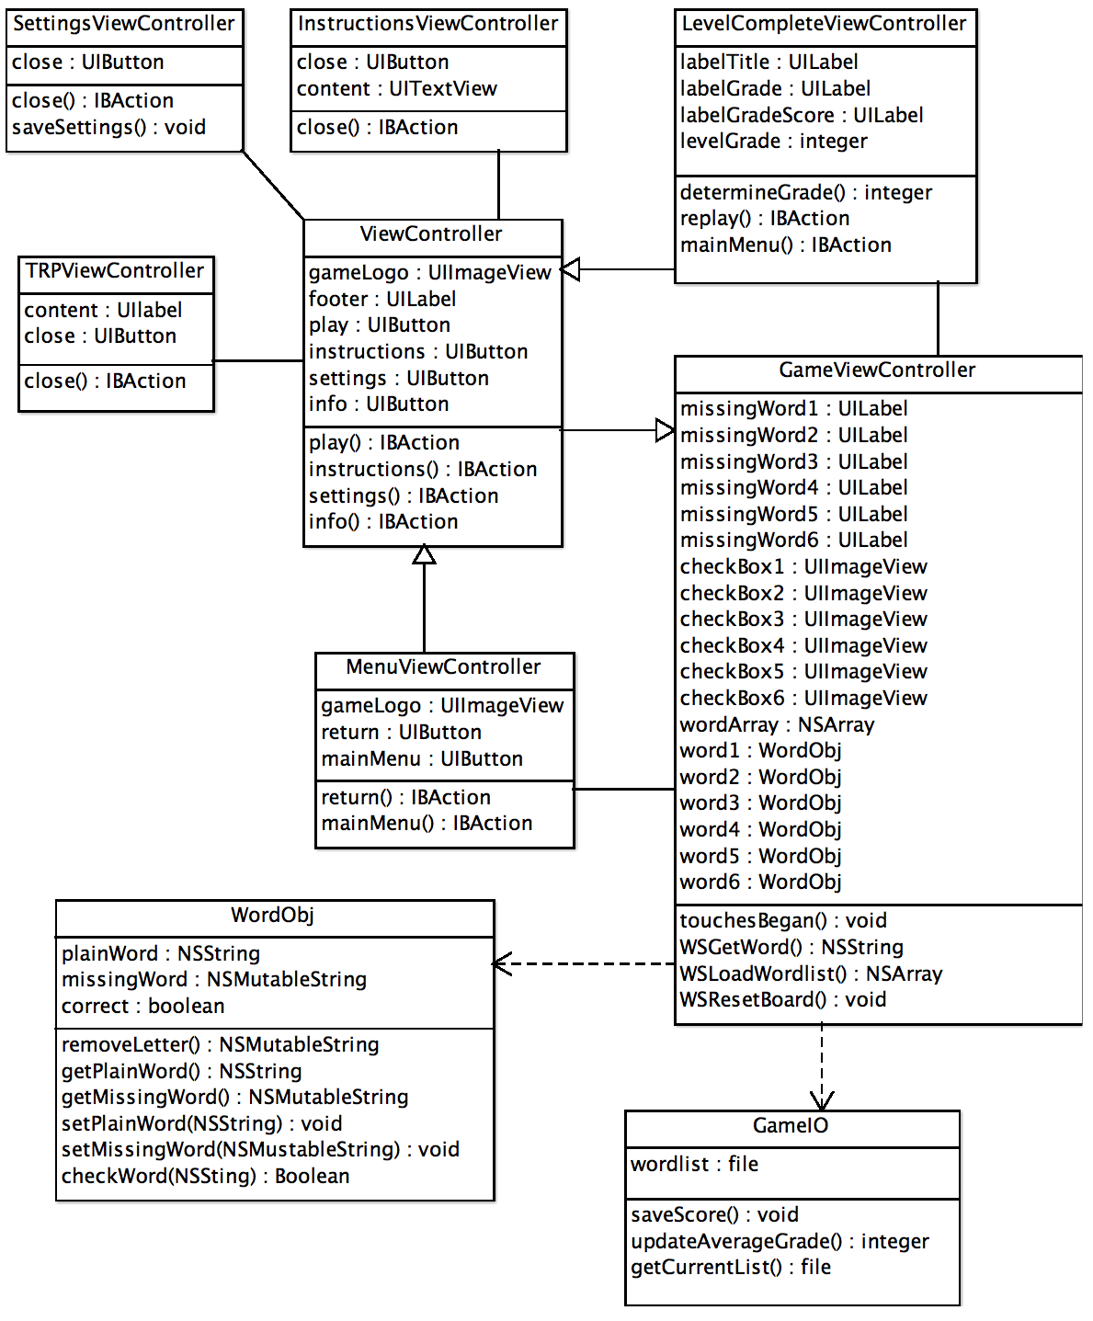

This UML Diagram show the different classes used in Missing Letters and how they interact with each other. This looks very similar to the Word Scramble diagram because the operation and main components of the games are identical, it is merely the implementation of those components that changes. Some action and UI element may not be show in this diagram as they are automatically defined by the Xcode storyboard editor.

Generic Menu Network
This is a Network Diagram which shows all the possible navigation and even paths possible in the game. The black dot at the center top of the diagram depicts when the user first starts up the game. The bubbles represent current screens or actions being performed. The arrows direct you to the various screens or actions based on the current state as labeled on the arrow.

Data Requirements

Game Content Data

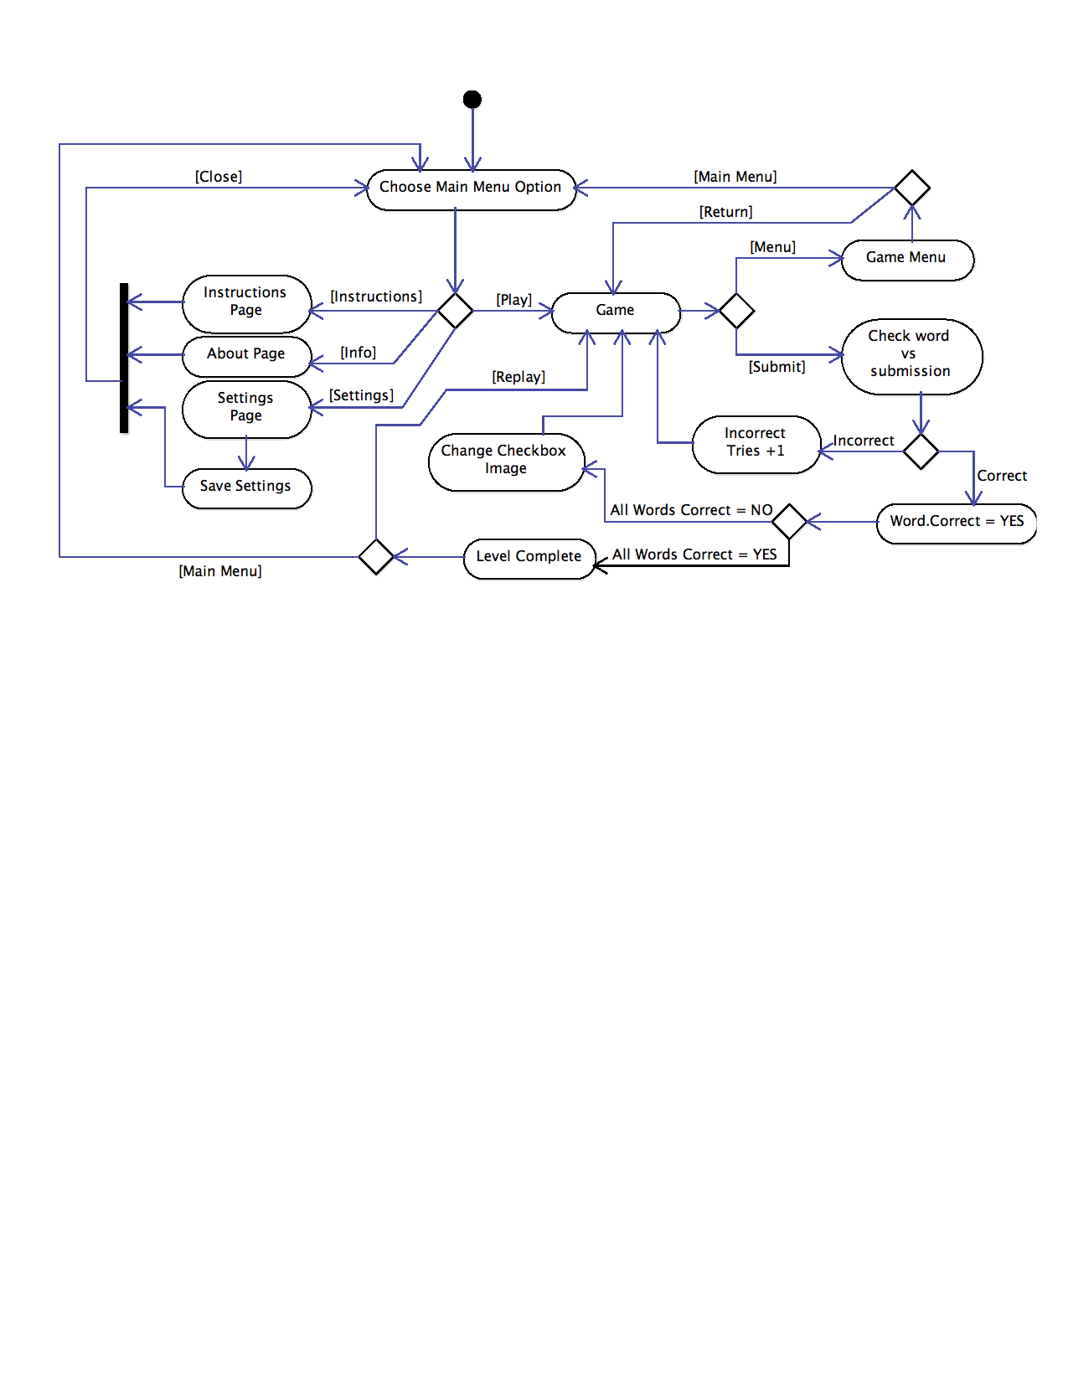

The content for the game will be hosted on an external server and will require an internet connection to access the most up-to-date data. The data on the server for version 1 will be a plain text file while in version 2 it will be changed to the JSON format. When a user opens the app, it will check to see if they have an active internet connection. If an active internet connection is present, the app will then download the current data file and store it on the device. If no internet connection is present, the app will load up with the data file that is currently stored on the device.

In version one, there will be a single universal data file that the app accesses. In following versions it will access user specific data based on username. The app will then go to the specific user’s directory and download their specific file.

There will also be a local datafile which stores statistics such as the average grade.

Settings Data

The settings set in the settings screen of the app will be stored in the settings.config file of the app. This will include settings such as username and password, among other possible settings in future versions.

User Interaction

The user will interact with the system through the default iOS keyboard as well as with the device’s touch interface. There is no special hardware required to operate either of the apps.

Feature Priority

Version 1
- Universal Wordlist (Text file)
- Pause Menu
- Settings Screen
- Instructions
- Level completion screen

Version 2
- User Specific Wordlists (JSON file)
- Level feedback/grade
- Basic statistics tracking (Average grade)
- Improved backend system (Server)

Version 3
- Dynamic “Extra Practice” mode which generates straight from SynPhony (Given API properly supports this feature)
- Performance enhancements and optimizations
- Improved UI and graphics

